Person conducting assessment: |  | Date of event:
Location of Activity or Event:
Activity Co-ordinators/Volunteers:
Describe the walk/activity or event and its purpose:
First Aid Officers :
Assess the risks and hazards of the activity
Issues to consider when assessing the activity or event: (Note the following is not an exhaustive list)
1. Where is this activity occurring? Is this under the Facilitator’s Venue’s or another’s control? Is a current signed indemnity form held? Has a COVID Warden’s approval been obtained?
2. Is this activity being run solely by the Facilitator or does it include other organisers (e.g. by venue or external contractors?) If yes, obtain copies of current public liability and professional indemnity insurance certificates and or qualifications, and safe operating procedures.)
4. How many persons will be involved in this activity or event at the one time? Are there any special needs? (e.g. disability, mobility,aged, prisoners etc) Are sufficient numbers of qualified and accredited assistants / volunteers and First Aid officers present?
5. Will children be involved? If so,do persons supervising children have a current “Blue Card”?
6. Is there anything on the site or used in the activity or event that has the potential to become a hazard, is hard to see (latent issue) and likely to cause harm to a person?
7. Are amusement devices included in the activity e.g. jumping castles, climbing equipment, compressor, machinery etc? Have maintenance records been provided and reviewed? Is equipment or machinery isolated from access?
8. Will food or alcohol be supplied for sale or consumption? Consider food safety measures and need for liquor license.
9. Is a traffic plan required where pedestrians and traffic will interact?
10. Consider the security of the event, adequate lighting, handling of money, storage of valuables, fire hazard (e.g. use of candles), possibility of community “walk-ins” / animals / other disruption, Sun, Weather and Covid safety measures and signage
11. Electrical safety: use residual current devices or safety switches where possible, check condition of leads no double adapters and keep leads away from water and walkways
12. Have clearly outlined rules and instructions on how the event will operate been provided and have supervisors or leaders been briefed on the walk /activity and their roles to ensure safe practice? Has Venue, Safety and Event Orientation been provided to leaders and volunteers?
13. Consider Privacy + Intellectual Property Risk Is there any need for permissions to use resources, written materials, graphics, photos (up front if may be taken at event), music etc?
Complete the assessment on the next page……

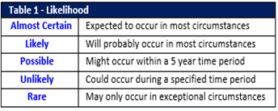 | 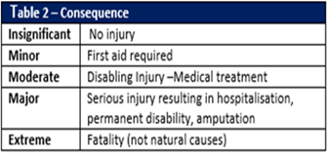 |  |  | 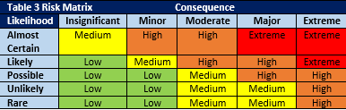 |  | 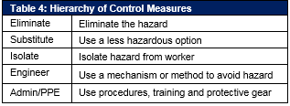
Low – Medium = Safe to proceed |  | High = Unsafe, controls must be reviewed |  |  | Extreme = Unsafe do not attempt activity
Step 1  List identified hazards and risks | Step 2  Likelihood (Table 1) + Consequence (Table 2)  = Risk level (Table 3) |  | Step 3  Using the Hierarchy of Control Measures (Table 4) identify suitable control measures to eliminate or minimise the level of risk |  |  |  | Has the risk level reduced?  If controls are implemented what is now the level of risk?
Hazard or Risk | Risk Rating |  | Control Measures - Actions to be Taken |  |  |  | Y/N - Residual
example  Stairs are a HAZARD,  Slipping and falling is the RISK | With no controls:  i.e.  HIGH, EXTREME |  | i.e.  Install handrails, improve lighting, non-slip edging, signs (to use handrail or caution), communicate to use ramps, communicate to use handrails, monitor |  |  |  | Should be lower than initial assessment  i.e. LOW
example  A ladder is the HAZARD  Falling is the RISK | With no controls:  i.e.  HIGH, EXTREME |  | - work from the ground (extension poles), |  |  |  | LOW
 |  |  | - only physically-capable person to use ladder, second person to support ladder, ladder set up only on flat ground, 3 point of contact at all time, load rated ladder used, ladder inspected for damage |  |  |  | MEDIUM
Low – Medium = Safe to proceed |  | High = Unsafe, controls must be reviewed |  |  | Extreme = Unsafe do not attempt activity
Step 1  List identified hazards and risks | Step 2  Likelihood (Table 1) + Consequence (Table 2)  = Risk level (Table 3) |  | Step 3  Using the Hierarchy of Control Measures (Table 4) identify suitable control measures to eliminate or minimise the level of risk |  |  |  | Has the risk level reduced?  If controls are implemented what is now the level of risk?
Hazard or Risk | Risk Rating |  | Control Measures/Actions to be Taken |  |  |  | Y/N - Residual

Outcome of Risk Assessment (apply the legend above and tick ✓)
Safe | □ | Unsafe (requires review of controls) |  | □ | Unsafe (activity is not to be attempted) |  | □
Sign-off to confirm activity and controls are acceptable and able to occur
Labyrinth Facilitator |  |  |  |  |  | Date:

